# **Lesson Objectives**

1. Addition or subtraction of matrices
2. Scalar multiplication of a matrix
3. Multiplying matrices

# Addition or subtraction of matrices

In order to either add or subtract matrices, they must have the **SAME dimension**.

* + - * **EXAMPLE:** Find $A+B$. [6.5.7]

$A=\left[\begin{matrix}7 & -9 \\ 8 & 0\end{matrix}\right]$ $B=\left[\begin{matrix}-5 & -9 \\ 9 & -8\end{matrix}\right]$

To find $A+B$, simply add in **corresponding** positions.

* + - * **EXAMPLE:** Perform the matrix operation. [6.5-13]

$\left[\begin{matrix}-3 & 9 & 4\end{matrix}\right]-\left[\begin{matrix}4 & 3\end{matrix}\right]$ This is **not defined** – they are **not** the **same** dimensions.

# **Scalar multiplication of a matrix**

A **scalar** is like a coefficient (or “multiplier”) to a matrix. It works sort of like using the distributive property – multiply **all** elements in the matrix by that scalar.

* **EXAMPLE:** If possible, use the given matrices *A* and *B* to find the following.

**(a) $A+B$**  **(b) $3A$** **(c) $4A-3B$**  [6.5.13]

$A=\left[\begin{matrix}2 & -3 & 2 \\ 1 & 4 & 7 \\ -6 & -1 & 4\end{matrix}\right]$ $B=\left[\begin{matrix}-4 & 5 & 2 \\ 6 & 3 & 6\end{matrix}\right]$

**(a) $A+B$**  **is undefined** because they are **not** the **same** dimensions.

**(b) $3A=3\left[\begin{matrix}2 & -3 & 2 \\ 1 & 4 & 7 \\ -6 & -1 & 4\end{matrix}\right]=\left[\begin{matrix}3∙2 & 3\left(-3\right) & 3∙2 \\ 3∙1 & 3∙4 & 3∙7 \\ 3\left(-6\right) & 3\left(-1\right) & 3∙4\end{matrix}\right]=\left[\begin{matrix}6 & -9 & 6 \\ 3 & 12 & 21 \\ -18 & -3 & 12\end{matrix}\right]$**

NOTE: Multiplying by a scalar does **NOT** affect the dimensions of a matrix.

**(c) $4A-3B=4\left[\begin{matrix}2 & -3 & 2 \\ 1 & 4 & 7 \\ -6 & -1 & 4\end{matrix}\right]-3\left[\begin{matrix}-4 & 5 & 2 \\ 6 & 3 & 6\end{matrix}\right]$**

$4A-3B$**is undefined** because they are **not** the **same** dimensions.

* **EXAMPLE:** Find the following matrices where $A=\left[\begin{matrix}7 & -5 \\ 7 & -8 \\ 3 & 1\end{matrix}\right]$ and $B=\left[\begin{matrix}-2 & 5 \\ 7 & -9 \\ 6 & 5\end{matrix}\right]$.

(we will be using graphing calculator)

**a. $A+B$** **b. $-6A$** **c. $-9A-9B$**  [6.5.15]

First, you need to enter your matrices into your calculator

1. Press **2ND, $x^{-1}$**  (MATRIX), go to EDIT, **ENTER** for matrix [A]. 
2. Enter the dimensions of matrix [A]; in this problem, it’s 3 rows × 2 columns.
3. Enter each of the elements of the matrix. 
4. Press **2ND, MODE** (QUIT).
5. Repeat the process for matrix [B]. 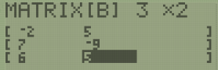

Next, to call up a matrix to do a calculation:

Press **2ND, $x^{-1}$**  (MATRIX), stay on NAMES, select your matrix, and press **ENTER**.

|  |  |  |
| --- | --- | --- |
| **a. $A+B$** | **b. $-6A$** | **c. $-9A-9B$** |
|  |  |  |
| $$A+B=\left[\begin{matrix}5 & 0 \\ 14 & -17 \\ 9 & 6\end{matrix}\right]$$ | $$-6A=\left[\begin{matrix}-42 & 30 \\ -42 & 48 \\ -18 & -6\end{matrix}\right]$$ | $$-9A-9B=\left[\begin{matrix}-45 & 0 \\ -126 & 153 \\ -81 & -54\end{matrix}\right]$$ |

# **Multiplying matrices – do NOT do this by hand! Use your CALCULATOR!**

Multiplying matrices is different than adding or subtracting matrices in two ways:

* You **don’t** multiply corresponding positions like how add or subtract works.
* The two matrices **don’t** necessarily need to have the **same** dimensions.

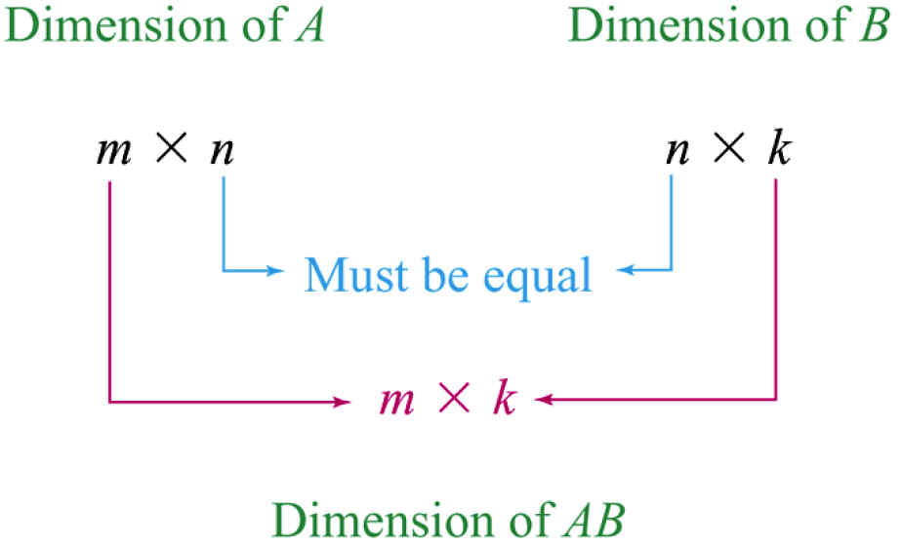

**How Matrix Multiplication Works**

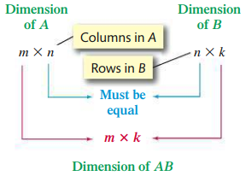 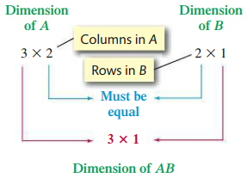

**NOTE: Do NOT do matrix multiplication by hand…EVER! Use CALCULATOR!!**

* **EXAMPLE:** Find (if possible) **a. $AB$** and **b. $BA$** , if [6.5.31]

$A=\left[\begin{matrix}2 & 4 \\ -4 & 4 \\ 5 & -3\end{matrix}\right]$, $B=\left[\begin{matrix}5 & -3 & -1 \\ -3 & 0 & -3\end{matrix}\right]$

|  |  |  |  |  |
| --- | --- | --- | --- | --- |
| **a. $AB$** means [A][B] on calculator. | |  | **b. $BA$** means [B][A] on calculator. | |
| First, check **dimensions** to see if multiplication even works. | | | | |
| Dimension of [A] | Dimension of [B] |  | Dimension of [B] | Dimension of [A] |
| $$\left[3×2\right]$$ | $$\left[2×3\right]$$ |  | $$\left[2×3\right]$$ | $$\left[3×2\right]$$ |
| Do inside numbers match? **YES** | |  | Do inside numbers match? **YES** | |
| If yes, look at **outside** numbers – that’s dimension of product matrix. | | | | |
| Product matrix [A][B] will be $\left[3×3\right]$ | |  | Product matrix [B][A] will be $\left[2×2\right]$ | |
| Use Calculator to find the matrix product | | | | |
|  | |  |  | |
| $$AB=\left[\begin{matrix}-2 & -6 & -14 \\ -32 & 12 & -8 \\ 34 & -15 & 4\end{matrix}\right]$$ | |  | $$BA=\left[\begin{matrix}17 & 11 \\ -21 & -3\end{matrix}\right]$$ | |

* **EXAMPLE:** Find the product of the following matrices, if possible. [6.5.29]

$$\left[\begin{matrix}7 & -8 & 4 \\ -6 & 0 & 8\end{matrix}\right]\left[\begin{matrix}6 & 2 & -2 \\ -8 & 9 & 7\end{matrix}\right]$$

Dimension of first matrix: $[2×3]$ Dimension of second matrix: $[2×3]$

Do the inside numbers match? **NO** **3** and **2**

Conclusion: **The multiplication is not possible**, even though they are same dimension.

Sources Used:

1. Pearson MyLab Math *College Algebra with Modeling and Visualization, 6th Edition*, Rockswold
2. Wabbitemu calculator emulator version 1.9.5.21 by Revolution Software, BootFree ©2006-2014 Ben Moody, Rom8x ©2005-2014 Andree Chea. Website <https://archive.codeplex.com/?p=wabbit>